

April 9, 2019

As a respected community member, and leader directly involved with children in Highlands County, we ask you to consider nominating one or more child advocates for the **20th Annual Judge Clifton M. Kelly Champion for Children Award.** The purpose of the Awards Gala is to honor and celebrate members of our community who go above and beyond to serve and positively impact our local youth. Please see the attached nomination form, also available on our website, and share with your family, friends, co-workers, and partner agencies.

Examples of those to consider nominating may include:

• Volunteers in programs working primarily with children.

• Professionals who give exceptional time, talents, and energies well beyond their occupational requirements to reach youth such as: Teachers, Coaches, Ministers, Law Enforcement Officers, and Social Workers.

• Mentors, dedicated to living out positive examples and spending time encouraging the next generation.

• Community members who have led the charge and dramatically impacted our community for the betterment of our children’s futures.

• Individuals who have shared their homes, churches and businesses to help provide a safe, nurturing environment, and strengthen our community’s families.

We appreciate your support in thanking and recognizing those who provide outstanding service to greatly improve the quality of life for children and youth in our community. Please contact the Champion for Children Foundation with any questions, and mark your calendars to join us in celebrating our exceptional child advocates at the 20th Annual Awards Gala on September 26, 2019.

**ALL NOMINATIONS MUST BE RECEIVED BY**

**JUNE 24, 2019.**

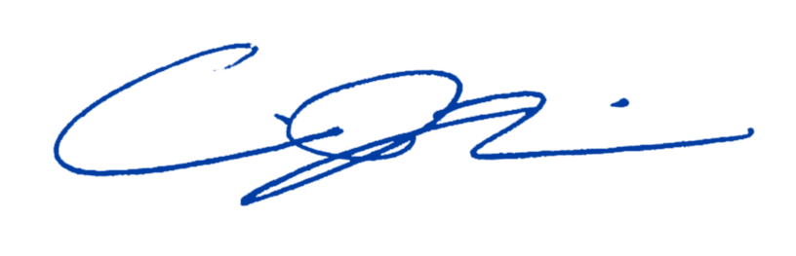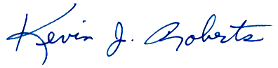Sincerely,

Kevin J. Roberts Carissa J. Marine

Founder/Chairman of the Board Chief Executive Officer